**LAB 09**

**Carpooling Chatbot**

1 2

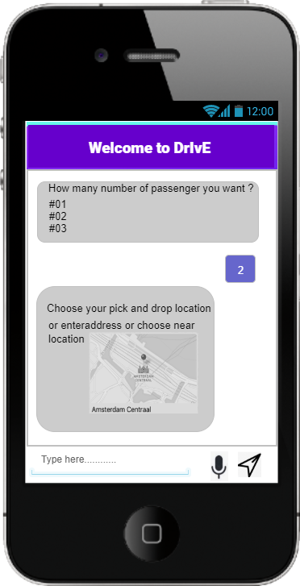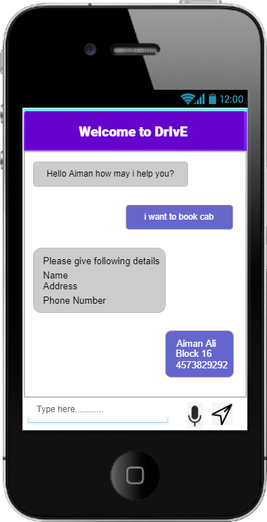

3 4

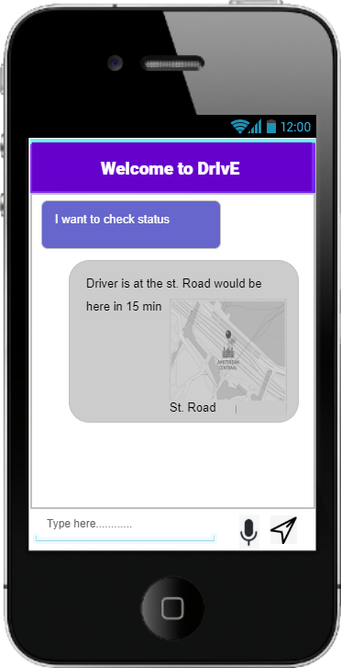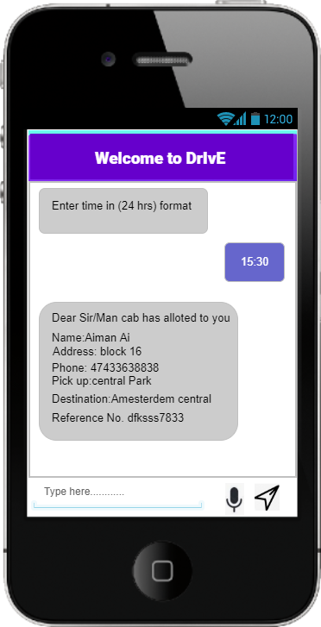

5 6

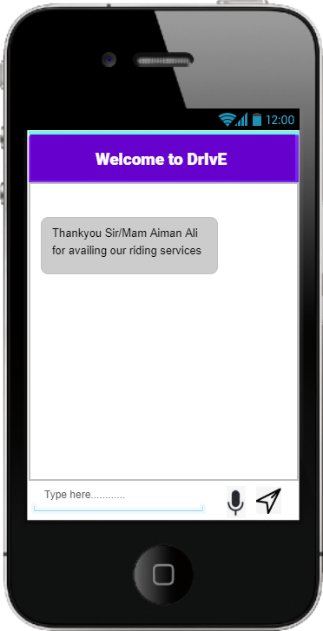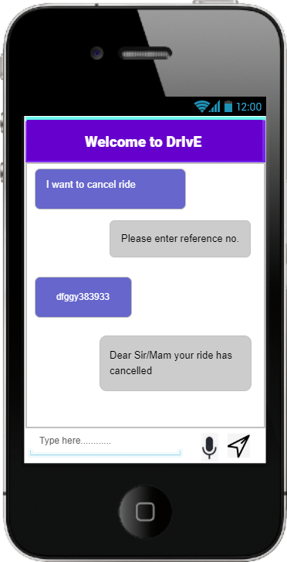

**Queries:**

* Book a cab
* Cancel ride (cab)
* Check status of car rider (ride)
* Give details like name, phone number, address
* Give details like Day, time, Pick and drop location
* Confirm message received

**Linear Flow**

Do you want to book a ride?

Book cab cancel ride check status

Provide details Give reference number Your rider is coming

Provide day, time, pick & drop location Ride cancelled

Provide number of person

Ride not available Ride available

Ride has confirmed